Topic heading | Syllabus Ref | Idea cluster | Question 1 | Question 2 | Question 3 | Question 4
Energy Changes | GCSE CEn(1) | Exothermic and Endothermic | A student carried out 4 investigations into temperature changes during reactions. The results are shown in the table.  Reaction Start Temp End Temp  X 20 17  Y 21 25  Z 18 29  W 19 19  Which statement is correct:  - The maximum temperature change is 10ºC  - Reaction X is exothermic.  - Reaction Y is exothermic.  - Reaction W is endothermic. | Which statement is correct:  - Bond making is endothermic  - Bond making is exothermic  - Bond breaking is exothermic  - No energy transfer occurs in a reaction. | In the below reaction bonds are broken and made:  H₂ + Cl₂ 2HCl  Using these bond energies calculate the overall energy change of the reaction.  H - H 432kJ/mol  Cl - Cl 240kJ/mol  H - Cl 428kJ/mol  - +1528 KJ/mol  - -1100 KJ/mol  - +244 KJ/mol  - -184 KJ/mol | Which statement is correct:  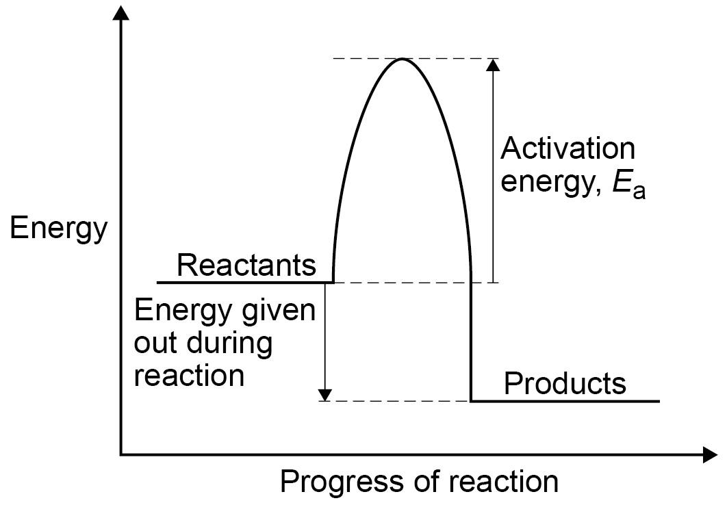  B  A  - This shows an endothermic reaction  - This shows an exothermic reaction  - Label A shows the overall energy change  - Label B shows the activation energy.
 |  |  | C | B | D | B
 | GCSE CEn(1) | Exothermic and Endothermic | The diagram below shows how the energy of the chemicals in a reaction changes.  Which statement is true about this reaction?  A  B  - A is the activation energy and B is the overall energy of the reaction. The reaction is exothermic.  - A is the overall energy of the reaction and B is the activation energy. The reaction is exothermic.  - A is the activation energy and B is the overall energy of the reaction. The reaction is endothermic  - A is the overall energy of the reaction and B is the activation energy. The reaction is endothermic | Which statement best describes endothermic reactions?  - Energy is transferred from the surroundings to the system to break bonds.  - Energy is transferred from the system to the surroundings, as bonds are broken.  - Energy is transferred from the surroundings to the system to make bonds.  - Energy is transferred from the system to the surroundings, as bonds are made. | Which statement best describes exothermic reactions?  - Energy is transferred from the surroundings to the system to break bonds.  - Energy is transferred from the system to the surroundings, as bonds are broken.  - Energy is transferred from the surroundings to the system to make bonds.  - Energy is transferred from the system to the surroundings, as bonds are made. | Which of the following changes is most likely to be exothermic?  - CO₂ (s) CO₂ (g)  - CaO (s) + H₂O (l) Ca(OH)₂ (s)  - CaCO₃ (s) CaO (s) + CO₂ (g)  - 2 Li₂O₂ (s) 2 Li₂O (s) + O₂ (g)
 |  |  | A | A | D | B
Energy Changes | GCSE CEn(2) | Cells and batteries | Use the reactivity series below to predict which combination of metals would produce the highest cell voltage.  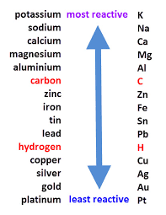  - Potassium and sodium  - Platinum and gold  - Zinc and iron  - Potassium and gold | Which of these reactions shows a correct balanced oxidation reaction?  - Cu²⁺ + 2e- Cu  - Mg Mg2⁺ + 1e-  - Cl⁻ Cl₂ + e-  - Zn Zn²⁺ + 2e- | Which is the correct statement?  - An anode is the negative electrode.  - A cathode is the positive electrode.  - Anions are attracted to the anode  - Anions are attracted to the negative electrode. | Which of the following is not an electrolyte?  - NaCl (l)  - NaCl (s)  - NaCl (aq)  - CuCl₂ (aq)
 |  |  | A | D | C | B
Energy Changes | GCSE CEn(3) | Hydrogen fuel cells | Which of the following statements accurately describes n advantage of hydrogen fuel cells over petrol as a fuel for cars?  - The cell itself does not produce any products that damage the environment.  - They use water as their fuel and so they are very cheap.  - They use hydrogen that requires no energy to produce.  - They are currently more expensive than petrol. | Which statements from 1-3 are correct about hydrogen fuel cells?  - Fuel cells only produce water.  - Fuel cells use hydrogen and oxygen  - Fuel cells are not rechargeable  - 1 and 3 is correct  - 2 is the only statement which is correct  - 1 and 2 is correct  - No statement is correct | Which is the correct balanced equation for a hydrogen fuel cell?  - H₂ + O₂ 2H₂O  - 2H₂ + O₂ 2H₂O  - H₂ + O₂ H₂O  - H₂ + 2O₂ 2H₂O | Most of the hydrogen used in hydrogen fuel cells is made by the electrolysis of water. Which of the following reactions does not occur during the electrolysis of water?  - 2H⁺ (aq) + 2e- H₂ (g)  - 4OH⁻(aq) O₂ (g) + 4H₂O(l) + 4e-  - 4H⁺+ 4OH⁻ 2H₂ + O₂ + 4H₂O  - H₂O (l) H₂ (g) + O₂ (g)
 |  |  | A | C | B | D
Using Resources | 4.9 | Potable Water | All of these statements are correct. What order should the statements go on?  - Chlorine or ozone is added to water.  - Water is collected in lakes and rivers  - Water is tested before pumping to home.  - Filter out the solids.  - 1 2 3 4  - 1 4 2 3  - 2 4 3 1  - 2 4 1 3 | To get potable water from salt water you need to desalinate it. These are four statements about desalination.  - This involves reverse osmosis.  - This requires a lot of energy  - Salt must be removed  - The sea is excellent supply of potable water  - Statement 1 only is correct  - All the statements are correct  - Statement 1, 2 and 4 only are correct  - Statement 1, 2 and 3 only are correct. | Which of these methods can be used to treat sewage:  - Filtration to remove grit  - Add chemicals to sediment small particles  - Use bacteria to digest sludge  - Distillation of the liquid.  Which statements are correct?  - Statement 1, 2 and 3 only  - Statement 1, 2 and 4 only  - Statement 3 and 4 only  - Statement 1 and 2 only
 |  |  | D | D | A
Using Resources | 4.9 | Recycling | Which of these definitions is correct:  - Electrolysis is the splitting of a substance using electricity  - Displacement is using a less reactive to replace a more reactive metal  - Phytomining is using bacteria to release a metal  - Bioleaching is using bacteria to release a metal | These are some different statements about manufacturing a product.  A High packaging cost Difficult to extract Very expensive  B Easy to dispose of Cheap raw materials No pollution  C High packaging cost No pollution Lasts a long time  D Pollution produced Expensive to produce Low transport costs  Which product is going to have the least environmental impact? | Which one of these substances would it be most economic to recycle?  Cost Cost when sold Use Process of recycling  A £70/kg £65/kg Water pipes and electricity Melting at a high temperature and recasting  B £50/kg £55/kg Toys, bottles and packaging Separating, melting at a low temperature, reforming.  C £60/kg £60/kg Bottles and Jars Separating, melting at a high temperature  D £65/kg £85/kg Rare metal in mobile phones Separating, melting at a high temperature and recasting.
 |  |  | A | B | D
Using Resources | 4.9 | Using Materials | A balanced symbol equation for the haber process is:  - N₂ + H₂ NH₃  - 2N₂ + H₂ NH₃  - N₂ + 3H₂ 2NH₃  - N₂ + H₂ 2NH₃ | Which objects can be protected using the method listed.  - A bridge - oiling  - Bicycle spokes – sacrificial protection  - Fishing trawler – electroplating  - Drain pipe and bucket - galvanising | Which row of the table is correct:  Made from? Use  A: Bronze Cu + Sn Taps  B: Brass Cu + Zn Cutlery  C: Low carbon steel C + Fe Car bodies  D: Stainless Steel Cr and Fe Statues | Which statement is correct:  A: Borosillicate glass is made from sand and boron trioxide  B: Soda lime glass is made from clay, limestone and sodium carbonate  C: Soda lime glass melts at a higher temperature  D: Borosillicate glass is used for drinking bottles
 |  |  | C | D | C | A
Using Resources | 4.9 | Using Materials | Which statement is correct:  A: Thermosoftening plastics do not melt  B: Thermosetting plastics do melt  C: LDP and HDP are formed from the same materials at the same temperature.  D: Thermosetting plastics contain cross links | What is a correct statement about the use of ammonia:  - Fertiliser  - Manufacturer of metal  - Electroplating  - Nitric acid
 |  |  | D | A

