Topic heading | Syllabus Ref | Idea cluster | Question
Electrical circuits | KS3 P3.1 | Electrical circuits | The correct definition for a current is:  - Rate of flow of charge past a point  - No. of electrons flowing past a point.  - Total no. of electrons in a circuit.  - How hard it is for an electron to flow.
 | KS3 P3.2 | Electrical circuits | The unit of electrical charge is:  - Ohm  - Volts  - Ampere  - Coulomb
 | KS3 P3.3 | Electrical circuits | Which of the following is a series circuit:  a)  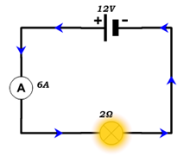  b)  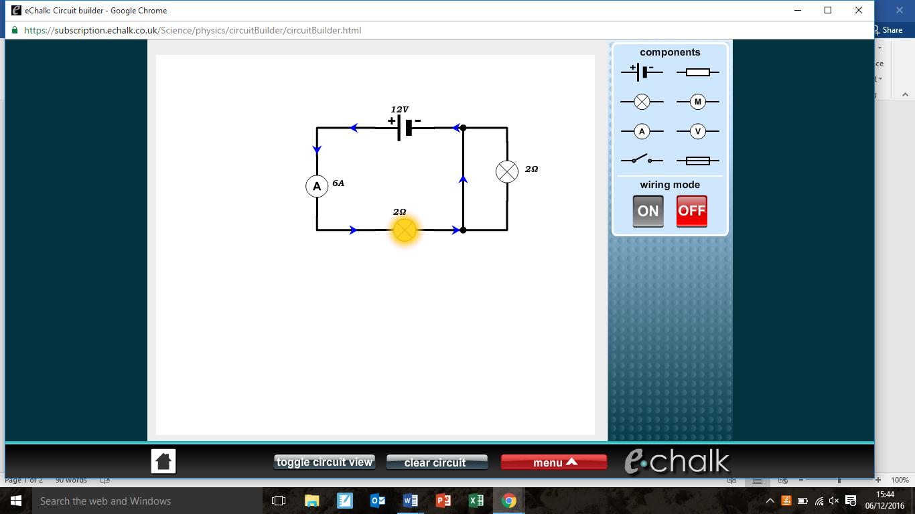  c)  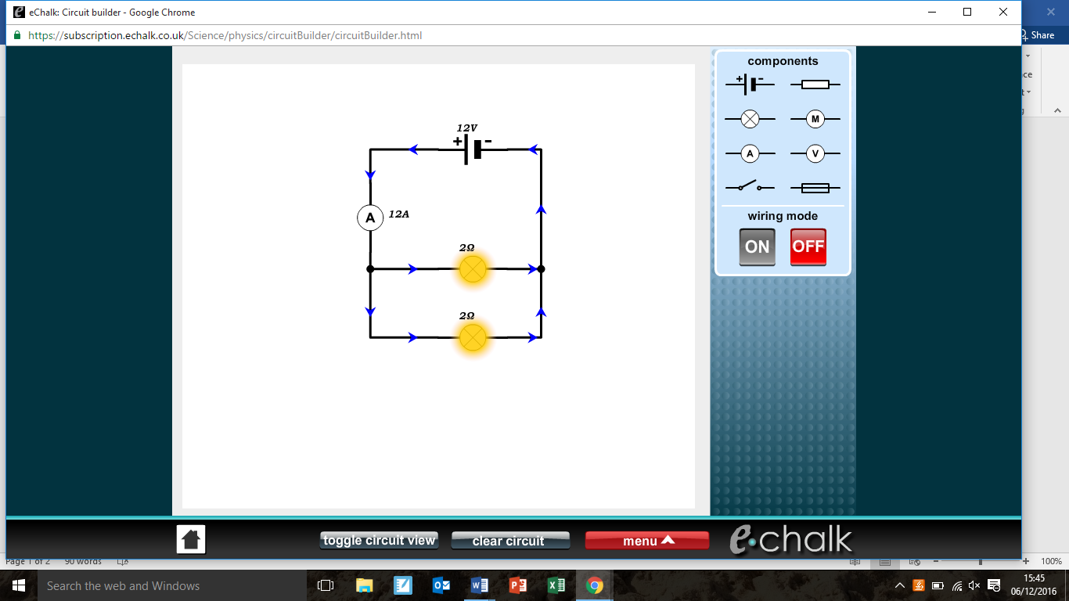  d)  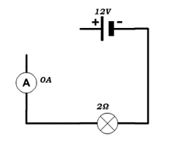
 | KS3 P3.4 | Electrical circuits | Explain how an ammeter measures current:  - Connected in parallel so current flows through it  - The quantum electron deflector measures flow.  - Connected in series so current flows through it.  - Connected in parallel so current cannot flow through it.
 | KS3 P3.5 | Electrical circuits | Why is current constant throughout a series circuit?  - The electrons follow the same route, they cannot disappear.  - Electrons travel at the same speed; it always adds up.  - Excess electrons disappear.  - Current is controlled by the power source.
 | KS3 P3.6 | Electrical circuits | What effect would a junction in a circuit have upon the current flowing?  - Current is split at this point.  - Current is doubled at this point.  - Current is halved at this point.  - Current is unaffected at this point.
 | KS3 P3.7 | Electrical circuits | If the reading on ammeter 1 I 4 A what will the reading on the second ammeter be?  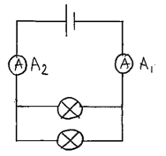  - 4 A  - 8 A  - 2 A  - 3 A
 | KS3 P3.8 | Electrical circuits | What is potential difference?  - Energy transferred to electrons.  - How much push electrons experience?  - Difference in the flow of electrons.  - How long a battery lasts for.
 | KS3 P3.9 | Electrical circuits | In which circuit is the voltmeter correctly positioned to measure the voltage of the lamp?  A 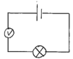  B 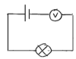  C 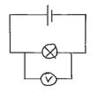  D 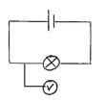
 | KS3 P3.10 | Electrical circuits | What is the common word for potential difference?  - Voltage  - Volts  - Coulombs  - Potential difficulty
 | KS3 P3.11 | Electrical circuits | If the reading on the first voltmeter is 6 V what will the reading on the second voltmeter be?  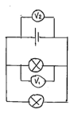  - 6 V  - 12 V  - 3 V  - 2 V
 | KS3 P3.12 | Electrical circuits | What will the readings be on voltmeters 1 & 2?  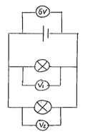  - V₁ 6V, V₂ 6V  - V₁ 3V, V₂ 3V  - V₁ 6V, V₂ 3V  - V₁ 4V, V₂ 2V
 | KS3 P3.13 | Electrical circuits | What is the formula for Ohm’s law?  - V = IR  - V = I/R  - V = R/I  - Ω = VI
 | KS3 P3.14 | Electrical circuits | What is the total resistance in this circuit?  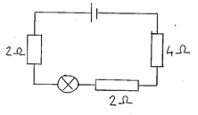  - 8Ω  - 16Ω  - 4Ω  - 32Ω
 | KS3 P3.15 | Electrical circuits | What is the total resistance in this circuit?  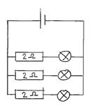  - 0.67Ω  - 2Ω  - 6Ω  - 8Ω
 | KS3 P5.1 | Electromagnetism | What charge does an atom have?  - Equal amounts of positive and negative charge.  - Positive  - Negative  - Expensive
 | KS3 P5.2 | Electromagnetism | If electrons are rubbed off a material, what is the resultant charge?  - Positive  - Negative  - Neutral  - No charge
 | KS3 P5.3 | Electromagnetism | Which diagram correctly shows the direction of the magnetic field around a simple bar magnet?  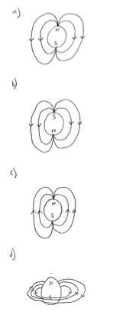
 | KS3 P5.4 | Electromagnetism | What would a physicist define as a field?  - An area where an object experiences forces without touching.  - An area where an object experiences forces with touching.  - An area where an object experiences no force.  - An area to grow things.
 | KS3 P5.5 | Electromagnetism | Which diagram best describes what happens to charge when a rubbed balloon is attracted to a wall?  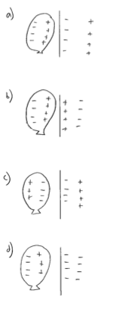
 | KS3 P5.6 | Electromagnetism | A compass is placed between two bar magnets as shown in the diagram below. In which direction will the compass point?  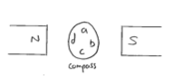
 | KS3 P5.7 | Electromagnetism | What happens to the iron filings when the switch is closed?  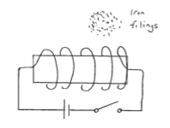  Iron core  - They will vibrate  - They will be attracted to the ends of the iron core  - They will be attracted to the middle of the iron core  - They will be repelled from the iron core
 | KS3 P5.8 | Electromagnetism | What happens to the wire when the switch is closed?  N  S  - The wire will spin  - The wire will be repelled from between the magnets  - The magnets will spin  - The magnets will become hot
 | KS3 P6.1 | Forces in fluids & gases | What happens when a balloon is inflated?  - Air particles colliding with a surface and imparting a force on it.  - Air particles on outside holding it inflated.  - Air particles expanding to inflate the balloon.  - Fewer air particles on outside allowing balloon to expand.
 | KS3 P6.2 | Forces in fluids & gases | If a balloon was inflated on the moon where there is no air what would happen and why?  - The balloon would inflate just like it does on Earth.  - The balloon would inflate more slowly because there is less gravity on the moon.  - The balloon would explode because there would be no air pressure pushing back against the balloon.  - The balloon would explode because there is so much air pressure on the moon.
 | KS3 P6.3 | Forces in fluids & gases | Which is the correct equation for pressure?  - P = F/a  - P = F x a  - P = F x a²  - P = a²/F
 | KS3 P6.4 | Forces in fluids & gases | When a cork is in water two forces act upon it, weight and upthrust. Which picture best describes the forces on the cork when it is floating on the surface?  B  A  C  D
 | KS3 P6.5 | Forces in fluids & gases | Which statement explains best why the person can float and read the newspaper?  - Upthrust from the sea is greater than the weight as the sea is denser.  - Upthrust from the sea is less than weight as the sea is denser.  - Upthrust from the sea is greater than weight as the sea is less dense.  - Downthrust from the person is less than the sea.
 | KS3 P6.6 | Forces in fluids & gases | Which is the incorrect arrangement of the density equation?  - ρ = m/v  - m = ρv  - v = m/ρ  - ρ = m x v
 | KS3 P6.7 | Forces in fluids & gases | Why do ships float of the surface of the water?  - Density of the ship is more than the sea.  - Density of the ship is less than the sea.  - Density of the ship is equal to the sea.  - Density of the sea is less than the ship.
 | KS3 P6.8 | Forces in fluids & gases | Why do submarines have thick external walls?  - Because water pressure decreases with depth.  - pressure is constant at any depth.  - Because water pressure increases with depth.  - To keep out the cold.
 | KS3 P7.1 | Speed | Which is the correct equation for speed?  - s = d/t  - s = d x t  - s = t/d  - s = mph
 | KS3 P7.2a | Speed | Which graph shows constant speed?  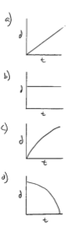
 | KS3 P7.2b | Speed | Which graph shows greatest distance travelled?  