Disciplinary knowledge and purposeful practical work in the secondary science classroom.

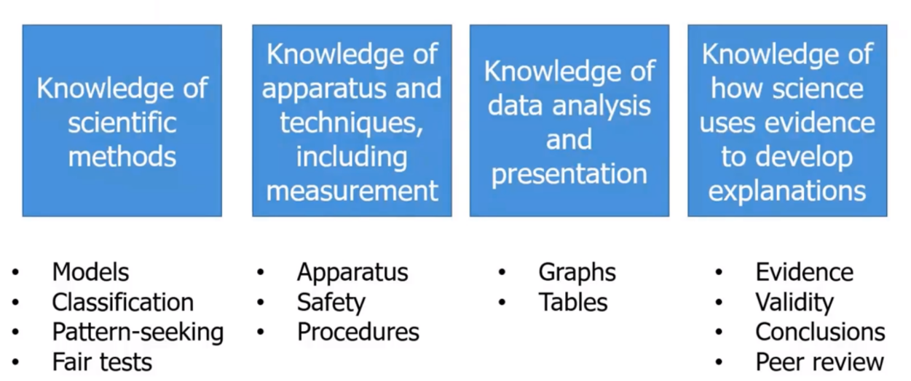
The language used to describe knowledge in science has evolved with our understanding of evidence-informed practice and embracing knowledge as the driving force in a curriculum. Disciplinary knowledge is defined as knowledge of how the discipline of science operates. It includes, but is not exclusively defined by, knowing how to carry out practical procedures. The main areas of disciplinary knowledge in science are illustrated below.

It’s important that in the science curriculum, thought has been given to where pupils are receiving exposure to these areas of knowledge. One way of doing this is by using a disciplinary knowledge exposure tracker. These documents allow you to track across a key stage when pupils are introduced to and develop fluency in, various aspects of disciplinary knowledge through various activities. It also ensures that thought around the sequencing of disciplinary knowledge is considered across the subject domains in science.
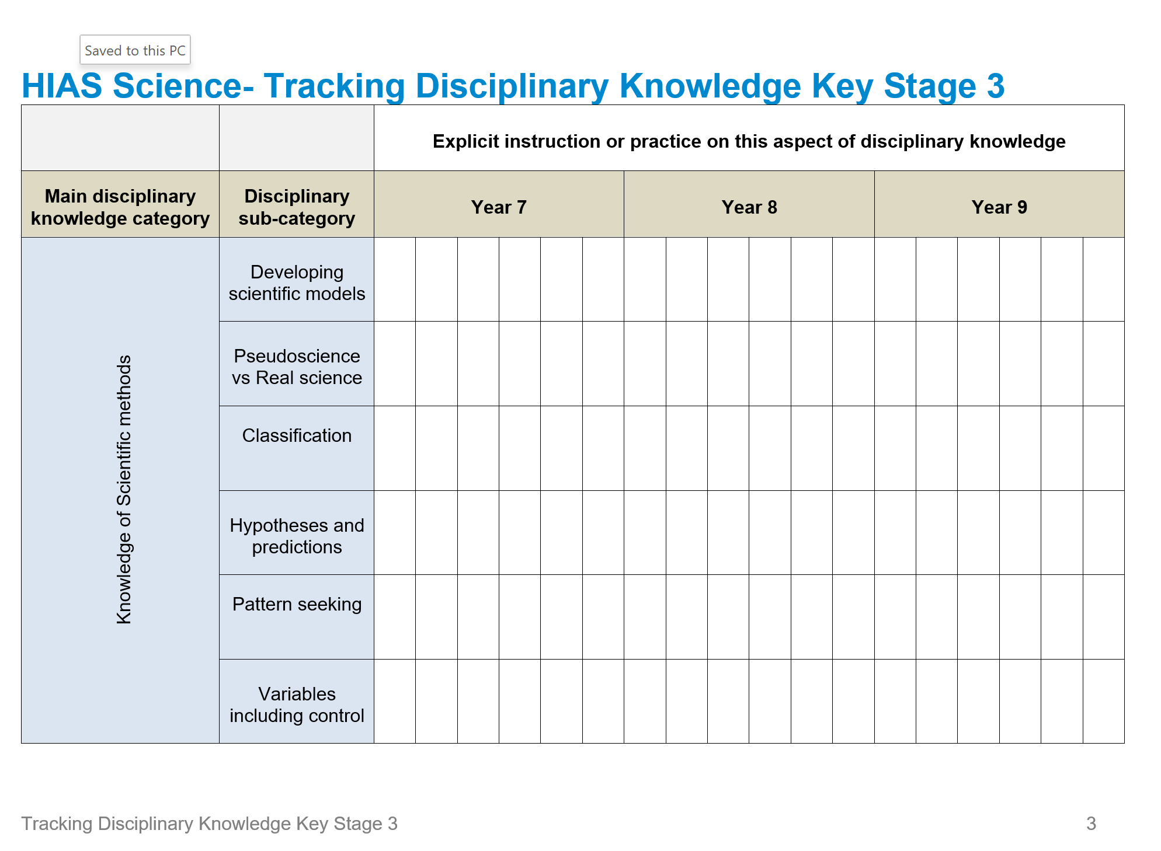
To do this the practicals you have in your curriculum need to be closely reviewed. The most important things to consider when doing practical work (apart from the obvious safety considerations) is the purpose of the activity and whether are pupils able to connect theory to practical work. This means that practical activities should be carefully placed in a sequence of learning so that they provide opportunities to apply or deepen substantive knowledge but also act as a vehicle for the delivery of specific aspects of disciplinary knowledge. The tracker allows either a teacher to monitor the exposure of their own classes to each aspect but even better it allows Heads of Science to map out this exposure over each key stage to ensure that pupils receive full coverage of all areas of disciplinary knowledge and opportunities to develop fluency.

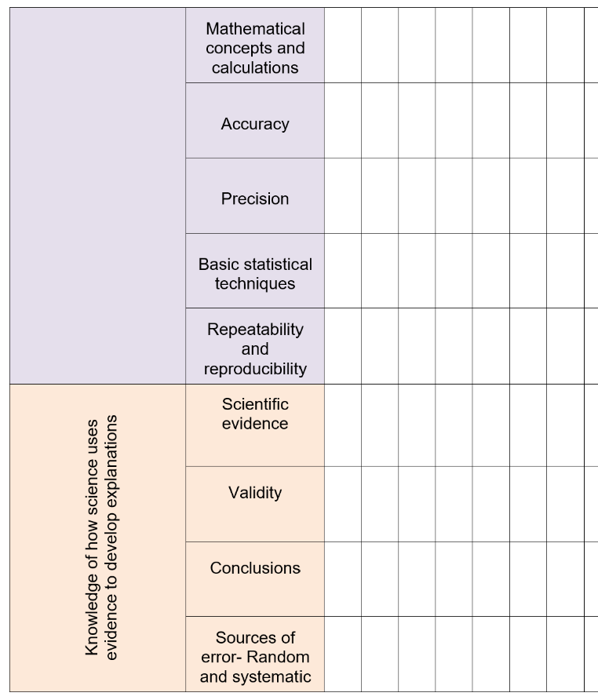
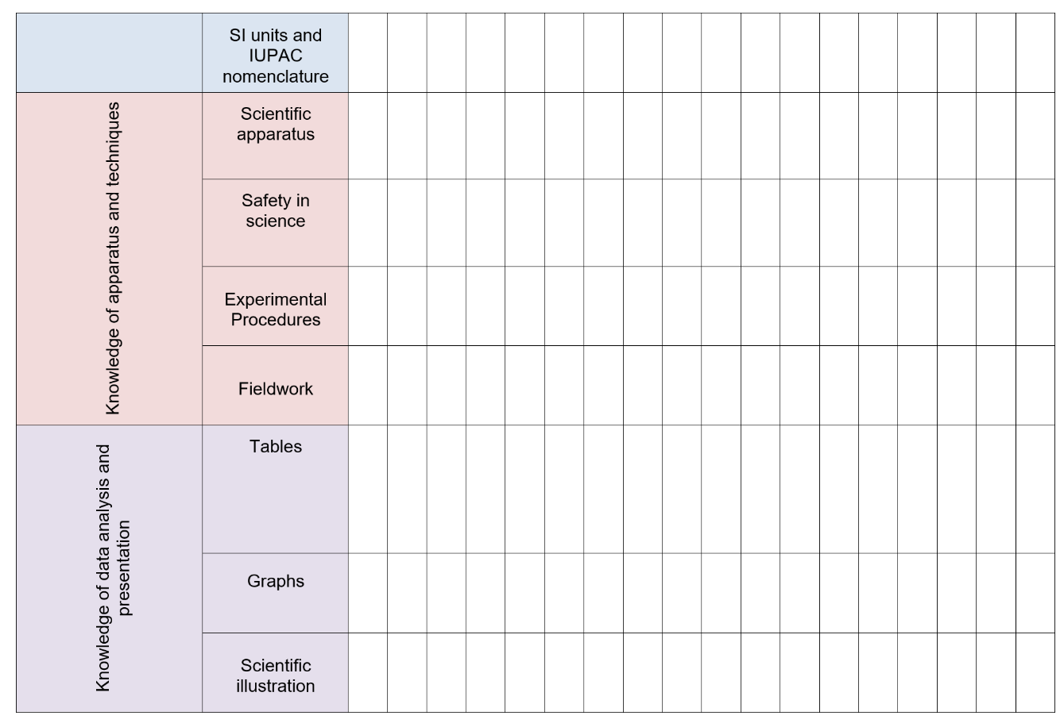

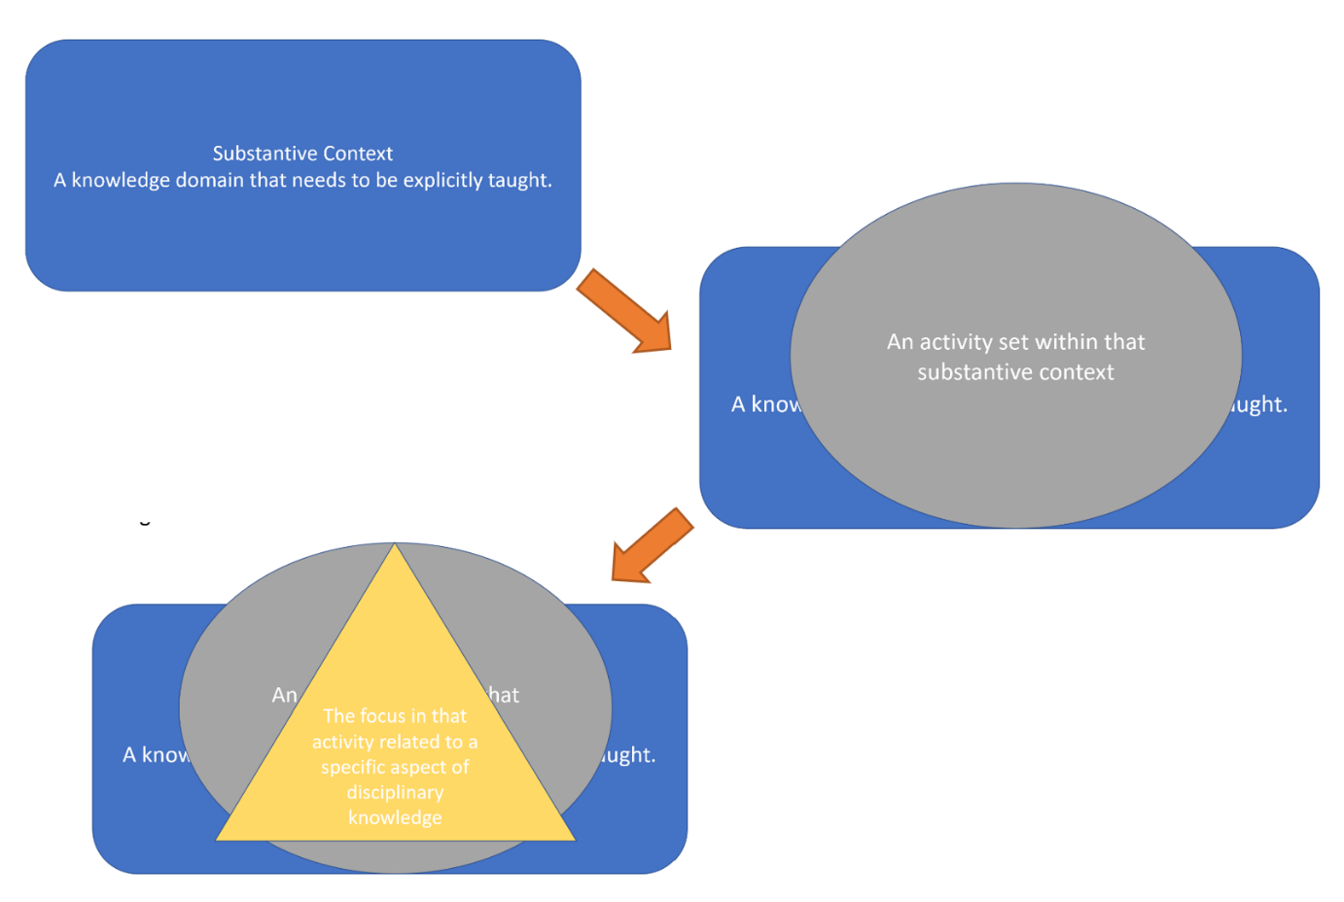
So how does this all look in practice? Below you can see a flow diagram which represents a simple model for the planning for the delivery of substantive and disciplinary knowledge.

First, we must consider the substantive domain we are currently in, cells, atomic structure, waves etc. Some substantive domains are appropriate for the delivery of some areas of disciplinary knowledge and others are not. It’s a choice based on which areas of substantive and disciplinary knowledge we are combining together. For example, the disciplinary area of Developing Scientific Models can only be combined with certain substantive topics like space, or models of the atom, whereas others can be placed in multiple domains.
This substantive knowledge must be taught and secure. It is unwise to use practical work as a direct delivery method for substantive knowledge so the theory must be taught first. Pupils are then ready to apply or deepen their understanding of the theory in the activity and will be able to connect what they are seeing in the practical to secure prior knowledge.
Within this substantive domain, there will be practical activities identified within the scheme of learning. These activities are your vehicle to introduce, develop or assess specific aspects of disciplinary knowledge. For most activities, two or three would be your upper limit to focus on in a single practical but sometimes focusing on just one aspect would be best, especially one of the larger more challenging aspects like graphing or variables.
Examples of this sequence would be:

Substantive domain:
The topic of cells-plant and animal cell structure KS4
Activity within that domain:
Looking at onion cells under a microscope
Purpose of activity linked to disciplinary knowledge:
- Scientific apparatus
- Scientific illustration
- Experimental procedures.

Substantive domain:
The topic of rocks and the properties of rocks KS3
Activity within that domain:
Which rock would be the best for building a house with?
Purpose of activity linked to disciplinary knowledge:
- Scientific hypotheses and predictions
- Conclusions

Planning for the sequencing and repeated exposure to disciplinary knowledge in the appropriate substantive domains will make sure over time pupils develop all the component knowledge required to become fluent scientific enquirers.
The disciplinary knowledge trackers are available to download from the HIAS Science Moodle+ page which is accessible with a subscription with gives you access to high-quality resources in science and all other subject areas.
Scan the QR code for more information on Moodle+

Kevin Neil
County Inspector/Advisor for Science

