Topic heading | Syllabus Ref | Idea cluster | Question 1 | Question 2 | Question 3 | Question 4
Homeostasis and response | BHo 1 | Homeostasis | What is homeostasis?  A When things in the body are kept the same.  B When the body maintains optimal conditions for enzyme action and all cell functions.  C When the body responds in a similar way to a stimuli  D When the body maintains a constant internal environment so that it can stay healthy. | Conditions that need to be controlled by the body are:  A Blood glucose, body temperature and water levels.  B Energy intake and energy output  C Blood and water  D Heart rate and temperature | What is the function of a receptor cell?  A To detect changes in the environment  B To tell the body how to respond to changes in the environment  C To bring about a response to changes in the environment  DTo receive and coordinate information. | Which of the following is an example of an effector?  A The brain  B The eye  C The adrenal gland  D The wrist
Correct Answer |  |  | B | A | A | C
Homeostasis and response | BHo 2 | The human nervous system | Which of the following best describes how the CNS coordinates a response to a stimulus?  - Stimulus receptor co ordinator effector response  - Receptor stimuli effector response.  - Co ordinator stimuli effector response  - Stimulus receptor effector coordinator response. | Which organs make up the Central Nervous System?  A Sensory and motor neurones  B Spinal cord and thigh muscle  C The eye and brain  D The brain and spinal cord | Why are reflex actions faster than a normal nervous response?  - Because the nerve impulses move faster in a reflex action  - Because nerve impulses do not involve the conscious part of the brain  - Because the response travels through fewer neurones.  - It travels across the synapses quicker | How does a nerve impulse move across the synapse?  - It jumps across the gap  - The neurotransmitter diffuses across the gap  - The impulse spreads out.  - The impulse starts again.
Correct Answer |  |  | A | D | B | B
Homeostasis and response | BHo 3 | Hormonal coordination | How is a hormonal response different to a nervous response?  A. With hormones the effect is faster.  B. With hormones the effect is slower  C. A nervous response lasts longer.  D. A nervous response takes longer to take effect. | What is the role of glands?  A To secrete chemicals called hormones  B To coordinate a response  C To produce an effect to a stimuli  D To speed up a response | Which of these is known as the master gland?  A Pancreas  B Thyroid  C Pituitary  D Ovary | 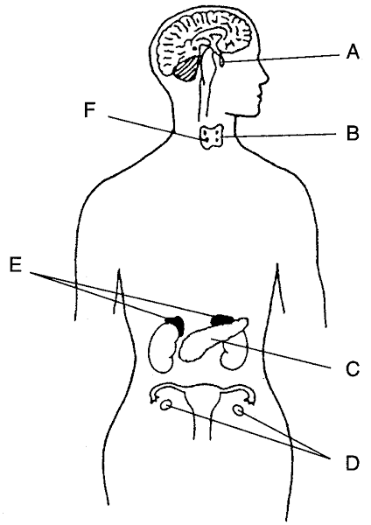  Which gland is labelled A?  A Ovary  B Adrenal  C Thyroid  D Pituitary
Correct Answer |  |  | B | A | C | D
Homeostasis and response | BHo 4 | Control of blood glucose | Which organ is responsible for the monitoring and control of blood glucose?  A Liver  B Pancreas  C Kidney  D Stomach | What is the role of insulin in controlling blood glucose?  - It causes glucose to move from the blood into the cells.  - It causes glucose to be produced by the liver.  - It makes the kidneys absorb glucose  - It stops the liver absorbing glucose | What is the name of the medical condition where a person does not produce enough insulin?  - Type 2 diabetes  - Pancreatitis  - Type 1 diabetes  - Jaundice | What is the treatment for type 2 diabetes?  A A carbohydrate controlled diet and exercise.  B Antibiotics  C Paracetamol  D Insulin injections
Correct Answers |  |  | B | A | C | A
Homeostasis and response | BHo 5 | Hormones in reproduction | Which gland is responsible for the production of oestrogen:  A Pituitary gland  B Adrenal  C Ovary  D Thyroid | What is the role of FSH ( Follicle stimulating hormone) in the menstrual cycle?  A Causes maturation of an egg  B Stimulates the release of an egg  C Maintains the lining of the uterus  D Prepares the lining of the uterus for a fertilised egg | What is the role of testosterone in reproduction?  A it makes a mans voice deeper.  B It stimulates sperm production  C It makes men grow taller.  D It makes men develop facial hair | Which hormone inhibits the secretion of FSH?  A Oestrogen  B Testosterone  C LH  D Progesterone
 |  |  | C | A | B | A
Homeostasis and response | BHo 6 | Hormonal control of fertility | Which hormone is present in the contraceptive pill to inhibit the eggs maturing?  A FSH  B LH  C Progesterone  D Oestrogen | Which hormones may be given to women to increase her fertility?  A oestrogen and progesterone  B FSH and LH  C FSH and Oestrogen  D Progesterone and LH | What is an advantage of IVF?  A The success rate is low  B It allows infertile couples to have their own baby.  C It is emotionally and physically stressful  D it can lead to multiple births
Correct Answers |  |  | D | B | B
Homeostasis and response | BHo 7 | Negative Feedback | What affect does adrenaline have on the body?  A It boosts the delivery of oxygen and glucose to the brain.  B It increases the size of the muscles in the arms.  C It plays a role in growth and development  D It speeds up chemical reactions in the body. | What is the role of thyroxine?  A It prepares the body for fight or flight.  B It stimulates the basal metabolic rate  C It increases heart rate.  D It controls the amount of glucose in the blood.
Correct Answers |  |  | A | B

