Topic heading | Syllabus Ref | Idea cluster | Question 1 | Question 2 | Question 3 | Question 4 | Question 5
Electricity | GCSEPE 1 | Electrical charge and current | Electrical current is a measure of what?  - The amount of energy that is transferred every second in J/sec  - The amount of charge passing every second in coulombs / sec  - The amount of energy transferred to each coulomb of charge by a power supply in J / coulomb.  - How much a component resists the flow of charge in ohms. | Current is measured in amps. 1 amp means what?  - Each coulomb of charge contains 1 J of energy.  - 1 J of energy is transferred to each coulomb every second.  - 1 coulomb of charge flows past a point in the circuit every second.  - 1 coulomb of charge flows past a point in the circuit every hour. | If a current of 2 amps flows for 1 minute the total charge flowed is:  - 2 coulombs  - 0.5 coulombs  - 120 coulombs  - 30 coulombs | Which of the following equations does not show the relationship between current, time and total charge flow?  - Q = I / t  - Q = I x t  - t = I / Q  - I = Q / t | Which statement about the current at positions 1, 2 and 3 in the circuit below is true?  1  2  3  - The current will be greatest at 1 and lowest at 2.  - The current will be greatest at 2 and lowest at 1.  - The current at 1 and 2 will be the same and lowest at 3.  - The current will be the same at all three points.
 |  |  | B | C | C | A | D
 | GCSEPE 2 | Current, resistance and potential difference | In which situation will the current be greatest?  - When the power supply has a high voltage and the resistance in the circuit is also high  - When the power supply has a low potential difference and the resistance in the circuit is also high.  - When the power supply has a high potential difference and the resistance in the circuit is low  - When the power supply has a low voltage and the resistance in the circuit is high | Which equation correctly describes the relationship between potential difference, current and resistance?  - I = V x R  - R = V x I  - R = V / !  - V = I x R | In a simple series circuit, the potential difference of the power supply is 6V; the total resistance in the circuit is 24 ohms. What current flows?  - 0.25 A  - 4 A  - 144 A  - 18 A | Which graph below describes a conductor that obeys Ohms Law?  I  V  I  V  I  V  I  V  A  B  C  D | In the circuit below the supply potential difference is 6 V. The lamp will blow if a current greater than 0.5 A flows but needs 0.1 A to flow for it to glow. What would be an appropriate resistor to add to the circuit?  - 6 Ohms  - 18 Ohms  - 120 Ohms  - 6000 Ohms
 |  |  | C | D | A | D | B
 | GCSEPE 3 | Resistors | Which graph below best describes how current varies with potential difference for an ohmic conductor?  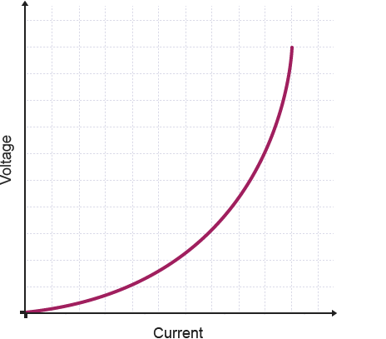  A  B  C  D  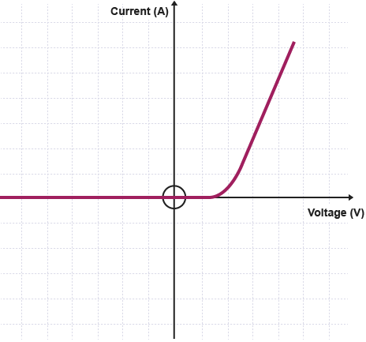  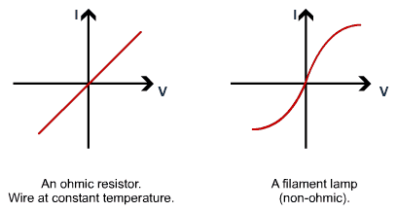 | Which graph below best describes how current varies with potential difference for a filament lamp?  A  B  C  D | Which graph below best describes how current varies with potential difference for a diode?  A  B  C  D | Which statement about light dependent resistors is accurate?  - Its resistance drops as the light intensity increases.  - The current passing through it drops as the light intensity increases.  - Its resistance increases as the light intensity increases.  - Its resistance drops as the light temperature increases. | Which statement about thermistors is accurate?  - Its resistance drops as the temperature decreases.  - The current passing through it drops as the temperature increases.  - Its resistance increases as the temperature increases.  - Its resistance drops as the temperature increases.
 |  |  | D | C | B | A
 | GCSEPE 4 | Series and parallel circuits | What is the total resistance in the circuit below?  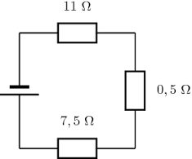  - 11 ohms  - 3 ohms  - 19 ohms  - 0.5 ohms | The circuit below contains two identical resistors; a lamp and a 9 V power supply. The current is 0.5 A. If the resistance of the lamp is 2 ohms what is the resistance of each resistor?  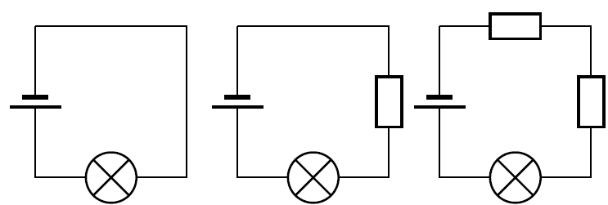  - 18 ohms  - 9 ohms  - 4.5 ohms  - 2.25 ohms | What could the resistance either side of the cell in the circuit below?  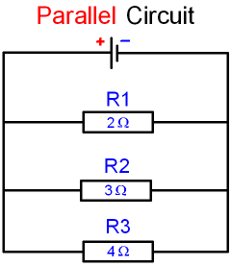  - 1 ohm  - 2 ohms  - 7 ohms  - 4 ohms | Which sum correctly describes the current measured at ammeter A1?  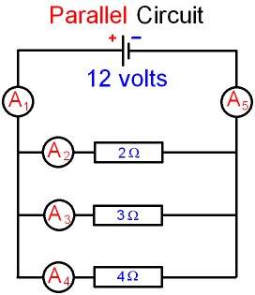  - A₁ = A₄ – A₃ – A₂  - A₁ = A₄ + A₃ + A₂ + A₅  - A₄ – A₃ – A₂ – A₅  - A₁ = A₄ + A₃ + A₂ | A series circuit contains a power supply and three resistors. One of the resistors is removed. What will definitely happen to the current?  - The current will drop by one third.  - The current will increase by one third.  - The current will decrease.  - The current will increase.
 |  |  | C | B | A | D | D
 | GCSEPE 5 | Direct and alternating current | What type of current is produced when a circuit is connected to a cell?  - Alternative current  - Alternating current  - Direct current  - Direct and alternating current | Mains current has the following properties:  - It has a voltage of 230V and a frequency of 230 Hz  - It has a voltage of 50V and a frequency of 230 Hz  - It has a voltage of 230V and a frequency of 50 Hz  - It has a voltage of 50V and a frequency of 50Hz | Which graph of voltage against time best describes how the voltage changes with time in an alternating current circuit?  V  Time  V  Time  V  Time  V  Time  A  B  C  D | Which graph of voltage against time best describes how the voltage changes with time in an alternating current circuit?  V  Time  V  Time  V  Time  V  Time  A  B  C  D | What kind of current is generated at a power station?  - Alternative current  - Direct current  - Direct and alternating current  - Alternating current
 |  |  | C | C | B | A | D
 | GCSEPE 6 | Mains electricity, insulation, fuses and circuit breakers | Three core electrical cables use colours to show what the wires are for. The correct colours are:  - Brown = live wire, blue = neutral wire and green and yellow stripes = earth wire.  - Blue = live wire, brown = neutral wire and green and yellow stripes = earth wire.  - Brown = live wire, green and yellow stripes= neutral wire and blue = earth wire.  - Green and yellow stripes= live wire, blue = neutral wire and brown = earth wire. | What is the role of the earth wire?  - To carry the alternating current from the supply.  - To complete the circuit.  - To act as a fuse  - To stop the appliance becoming love. | The potential difference between the live wire and the earth is?  - 240 V  - 50 Hz  - 230 V  - 40 Hz | Sometimes appliances do not have earth connections. This is usually if?  - They are made of metal  - They are double insulated  - They are broken  - They use mains electricity | How are fuse wires are different from wires in the circuit?  - Fuse wires are much stronger so they don't burn out.  - They are thinner and burn out more easily than the wires in the circuit.  - They are the same but aren't insulated.  - Fuse wires only allow current to pass in one direction.
 |  |  | A | D | C | B | B
 | GCSEE 6 | Power | Which of the following equations shows an incorrect relationship between power, voltage and current  - P = V x I  - V = P / I  - V = I / P  - P = I x V | Which of the following equations describes how power, current and resistance are related?  - P = I x R  - P = I² x R  - P = I x R²  - P = I / R | 0.1 A passes through a device connected to the mains supply. What is the power of the device?  - 23 W  - 230 W  - 2300 W  - 0.0004 W | A 23 kW machine is connected to the mains. What current would flow?  - 230 W  - 529 W  - 0.1 A  - 100 A | Power is measured in watts. 1 W means?  - 1 J of energy is transferred in total  - 1 J of energy is transferred every second  - 1 J of energy is transferred every minute  - 1 j of energy is transferred for ever m of wire.
 |  |  | C | B | A | D | B
 | GCSEPE 7 | Energy transfer in everyday appliances | Which equation shows the total amount of energy transferred by a device of power rating P in time t?  - E = P x t  - E = P / t  - E = t x P  - E = P² / t | A 1 kW hair dryer is used for 2 minutes. How much work was done?  - 120 J  - 120 kJ  - 60 J  - 60 kJ | In the equation E = Q x V, what does Q mean?  - The current  - The charge per second  - The total number of coulombs.  - The potential difference | A circuit was connected to a 9 V power supply and the total charge that flowed was 100 C. How much work was done?  - 900 J  - 900 W  - 900 A  - You can’t tell unless you know how long the current flowed for | In which situation was the energy transfer greatest?  - 2 kW hairdryer on for 1 minute  - A 30 W electric bulb on for 100 minutes.  - A 10 kW fan heater for 10 seconds  - A 10 W torch for 10000 seconds
 |  |  | A | B | C | A | B
 | GCSEPE 8 | The National Grid | Step up transformers do the following:  - They increase V and I  - They decrease V and I  - They increase V and decrease I  - They decrease V and increase I | Step-up transformers are used to increase the potential difference from the power station to the transmission cables because?  - Power cables can’t manage low voltages  - Too much energy is transferred from power cables at high currents.  - Electricity travels faster at high voltages.  - Low voltages cause problems for birds | What is the correct description of how the national grid uses transformers?  - Step up upon going from power station to transmission cables and step down upon entering homes and factories.  - Step up upon going from power station to transmission cables and step up upon entering homes and factories.  - Step down upon going from power station to transmission cables and step down upon entering homes and factories.  - Step down upon going from power station to transmission cables and step up upon entering homes and factories. | The system of cables and transformers linking power stations to consumers is called what?  - Powrgen  - The international Grid  - National Power  - The National Grid
 |  |  | C | B | A | D
 | GCSEPE 9 | Static Charge | What is transferred when an object gains a static charge?  - Electrons  - Voltage  - Atoms  - Protons | A spark can leap from an object with a static charge to another object if?  - The other object is a metal  - The other object is an insulator  - If the potential difference between the two objects is high enough.  - If a wire is placed between the two objects | Two identical insulators gained static charges when rubbed by identical clothes. The two objects were brought close to each other. What might be observed?  - A spark would jump between the two objects.  - The two objects would attract each other  - The two objects would attract each other and a spark might jump between them.  - The two objects would repel each other | Very different clothes rubbed two identical balloons. When brought close to each other the balloons were attracted to each other. Which statement is correct about the two balloons?  - Both balloons have positive charges  - Both balloons have negative charges  - Both balloons transferred electrons to their cloths/  - Only one balloon transferred electrons to its cloth.
 |  |  | A | C | D | D
 | GCSEPE 9 | Electric fields | The area around a charged object where other charged objects will be attracted or repelled is called what?  - An electric field  - A magnetic field  - An electric current  - A magnet | The attractive and repulsive forces between electric fields are examples of what?  - Contact forces  - Magnetic forces  - Non-contact forces  - Gravitational forces | Which picture best describes the electric field around a positively charged ball?  +  -  +  -  A  B  D  C
 |  |  | A | C | A

