***I do, we do, you do SLOP***

***Shed Loads of Practice Booklet***

**(SLOP)**

**Biology Topic 2**

**Organisation**

**Section 1 – Digestion**

**Section 2 – Food tests**

**Section 3- Enzymes**

**Section 4 – Lungs**

**Section 5- The heart**

**Section 6 – Blood and blood vessels**

**Section 7 – Non-communicable diseases**

**Section 8 – Cancer**

**Section 9 - Plants**

**Section 1- Digestion**

1. **Organisation**
2. What is the definition of a cell? Write this out 5 times.
3. What is the definition of a tissue? Write this out 5 times.
4. What is the definition of an organ? Write this out 5 times.
5. What is the definition of an organ system? Write this out 5 times.
6. **Digestive organs**
7. What are the 10 organs of the digestive system?
8. What is the function of the mouth in digestion?
9. What is the function of the oesophagus in digestion?
10. What is the function of the stomach in digestion?
11. What is the function of the liver in digestion?
12. What is the function of the small intestine in digestion?
13. What special structures does the small intestine have to help with its function?
14. What is the function of the large intestine in digestion?
15. What is the function of the rectum in digestion?
16. What is the function of the anus in digestion?

**Section 2 – Food tests**

1. What is used to test for starch?
2. What is used to test for protein?
3. What is used to test for lipids?
4. What is used to test for reducing sugars?
5. What is a positive result in the test for starch?
6. What is a positive result in the test for protein?
7. What is a positive result in the test for lipids?
8. What is a positive result in the test for reducing sugars?
9. A test for starch produced a brown/orange colour. Is this a positive result?
10. A test for proteins produced a purple colour. Is this a positive result?
11. A test for reducing sugar gave a green colour. What does this mean?
12. A test for reducing sugar gave a blue colour. What does this mean?
13. A test for reducing sugar gave a red colour. What does this mean?

**Section 3 – Enzymes**

1. What is a catalyst? Write this out 5 times
2. What type of catalyst is an enzyme?
3. Look at the diagram of an enzyme, what is the name for the part labelled A? 
4. What is the name for the substance that fits into part A?
5. What is the name for the model of enzyme action?
6. What are the 3 digestive enzymes?
7. Which enzyme is produced in the mouth?
8. Which enzyme is produced in the stomach?
9. Which enzymes are produced in the pancreas?
10. What are carbohydrates broken down into?
11. What are proteins broken down into?
12. What are lipids broken down into?
13. Name 3 factors that could affect the rate of enzyme action.
14. What does it mean if an enzyme is denatured?
15. What is the optimum temperature for enzymes in humans?
16. What would be an optimum pH for an enzyme found in the stomach?
17. What would be the optimum pH for an enzymes found in the small intestine?

**Section 4 – Lungs**

1. What is the part labelled A in the diagram?
2. What is the part labelled B in the diagram?
3. What is the part labelled C in the diagram?
4. What is the part labelled D in the diagram?
5. What is the part labelled E in the diagram?
6. What is the part labelled F in the diagram?
7. What is the function of the lungs?
8. How are the alveoli adapted to their function?
9. What does smoking do to your lung capacity?
10. Which chemical from cigarettes binds to the haemoglobin in your red blood cells instead of oxygen?
11. Name a disease that someone who smoked is at an increased risk of getting.

**Section 5 – The Heart**

1. **Structure of the heart**
2. Which part of the heart is labelled A?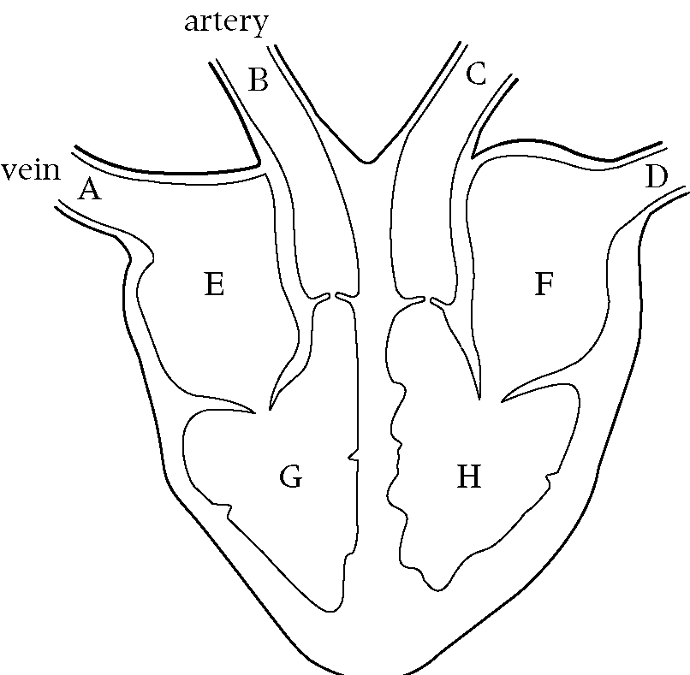
3. Which part of the heart is labelled B?
4. Which part of the heart is labelled C?
5. Which part of the heart is labelled D?
6. Which part of the heart is labelled E?
7. Which part of the heart is labelled F?
8. Which part of the heart is labelled G?
9. Which part of the heart is labelled H?
10. Which blood vessels take blood to the heart?
11. Which blood vessels take blood away from the heart?
12. Which side of the heart has oxygenated blood?
13. Which side of the heart has deoxygenated?
14. Describe the how deoxygenated blood enters the heart and then leaves as oxygenated blood.
15. **Heart Disease**
16. What is cardiovascular disease? Write this out 5 times.
17. What is coronary heart disease? Write this out 5 times.
18. What is arrhythmia?
19. What is a myocardial infarction?
20. What is heart failure?
21. What is heart valve disease?
22. Name 4 factors that could increase the risk of heart disease.
23. What is a stent and how does it work?
24. Name an advantage of a stent
25. Name a disadvantage of a stent
26. What are statins and how do they work?
27. Name an advantage of using statins
28. Name a disadvantage of using stains
29. What is a pacemaker and how does it work?
30. Name an advantage of a pacemaker
31. Name a disadvantage of a pacemaker
32. What are beta blockers and how to they work?
33. Name an advantage of beta blockers
34. Name a disadvantage of beta blockers
35. What is an artificial valve and how does it work?
36. Name an advantage of an artificial valve
37. Name a disadvantage of an artificial valve.

**Section 6 - Blood and blood vessels**

1. **The blood**
2. What are the 4 components of the blood? Write these out 5 times.
3. What is the function of red blood cells?
4. What adaptations do red blood cells have?
5. What is the function of white blood cells?
6. Where are red and white blood cells produced?
7. What is the function of platelets?
8. What is the function of plasma?

1. **Blood vessels**
2. What are the 3 types of blood vessel? Write these out 5 times.
3. What is the function of a vein? Write this out 5 times.
4. What is the function of an artery? Write this out 5 times
5. What is the function of a capillary? Write this out 5 times.
6. What are the features of a vein?
7. What are the features of an artery?
8. What are the features of a capillary?
9. Which blood vessel contain valves?
10. What is the function of the valves in a blood vessel?
11. Which blood vessel is 1 cell thick?
12. Why is this blood vessel one cell thick?
13. Which blood vessel has a thick muscular layer?
14. Why does this blood vessel have a thick muscular layer?

**Section 7 – Non-communicable diseases**

1. What is the definition of health? Write this out 5 times.
2. What is the definition of a disease? Write this out 5 times
3. What is a risk factor? Write this out 5 times.
4. What are the two types of disease?
5. Which type of disease of caused by a pathogen?
6. Which type of disease is not caused by a pathogen?
7. What is a communicable disease?
8. What is a non-communicable disease? Write this out 5 times.
9. Name 4 examples of a non-communicable diseases
10. For the non-communicable diseases, you listed in question j, state the risk factors of getting them.

**Section 8 – Cancer**

1. What is the definition of cancer? Write this out 5 times
2. What is different about tumour cells compared to normal cells?
3. What is a mutation? Write this out 5 times.
4. What is a tumour?
5. What are the 2 types of tumour?
6. What is a benign tumour? Write this out 5 times
7. What is a malignant tumour? Write this out 5 times.
8. Which type of tumour is not cancerous?
9. Which type of tumour is cancerous?
10. Name 3 risk factors of getting cancer

**Section 9 – Plants**

1. Structure of a leaf
2. Which part of the leaf is labelled A?
3. Which part of the leaf is labelled B?
4. Which part of the leaf is labelled C?
5. Which part of the leaf is labelled D?
6. Which part of the leaf is labelled E?
7. Which part of the leaf is labelled F?
8. What is the function of a leaf?
9. What adaptations do leaves have?
10. What are stomata? Write this out 5 times
11. What are guard cells? Write this out 5 times
12. **Transpiration and transportation**
13. What is the function of a root hair cell? Write this out 5 times
14. What is the function of the xylem? Write this out 5 times
15. What is the function of the phloem? Write this out 5 times
16. What is transpiration? Write this out 5 times
17. What is transportation? Write this out 5 times
18. Describe how water enters, moves through a plant and then exits.