**Literacy in Science**

Before we can look at some ideas and strategies we need to establish the difference between literacy in science versus scientific literacy as the two are often confused.

Science literacy means pupils have a solid understanding of the methodology of science. They understand the scientific method, and how this leads to the development of knowledge and understanding. Pupils are scientifically literate.   
Literacy in science is the ability to read and comprehend subject-specific texts like textbooks, scientific articles and at a certain level journal publications. It’s having a secure and deep tier three vocabulary which you can use to decode and articulate scientific problems and discoveries.

Explicit teaching of literacy is not always done in science or it’s given a superficial touch to adhere to some whole-school literacy policy. However, if students are to develop a clear understanding of science and become confident scientists, then they need to make sense of a variety of words, both scientific and non-scientific.

Developing scientifically literate pupils requires a clear map of progression through the different aspects of disciplinary knowledge in science and providing enough opportunities in your curriculum for pupils to develop mastery of these aspects. This is addressed in a different document within the Moodle resources.

Below are some ideas and strategies for teaching literacy in science

**Keywords and definitions**

Keywords and definitions are vital for students to know. However, when and how they are introduced is vital if they are to have any impact on learning and remembering. Many lessons seen will have the keywords up on the first slide of a PowerPoint and then never refer to them again. The words may be spoken and used in the lesson but there is rarely any specific teaching of the definitions of keywords. Let’s take a look at an example.

Imagine this situation:

**Teacher**- “*Well done on your retrieval practice. Now we are going to start a new lesson on the topic of Osmosis. On my PowerPoint, you will see a list of keywords and a definition of what osmosis is…Copy this into your books”*

*Osmosis is the net movement of water molecules from an area of high water concentration to low water concentration through a partially permeable membrane*

**Teacher-** *Lizzie, What’s osmosis?*

**Lizzie*- “****Osmosis is the net movement of water molecules from an area of high water concentration to low water concentration through a partially permeable membrane”*

**Teacher-** *“Brilliant Lizzie. You understand osmosis.”*

What is wrong with this use of definitions example?  
This definition works only for the teacher. The teacher already has the idea of osmosis and all the component pieces of knowledge that go with this, connected in their schema. The students are novices and although can repeat the words back, they don’t really understand the concept of osmosis. Simply copying down the key words and definitions is not enough.

The teacher in their own schema already knows what net movement, molecules, concentration, membranes, permeable, partially means. Each component is secure and the links between them are firm. It represents a domain of connected knowledge.  
For Lizzie and other students, these words are mostly unfamiliar and not connected.

Yes, we want a strong emphasis on choral responses in our classrooms to check for understanding. However, Lizzie doesn’t understand osmosis by simply recalling the definition she has written down moments ago.

So how can we make the introduction of new science-specific words easier? The definition of osmosis is far too large to teach as a single concept. Each word, permeable, membrane, concentration etc., needs to be explained, modelled and secure before connecting all of them together. This is best done through explicit teacher instruction using dual coding.

Dual coding involves showing the word and using an image or drawing to represent it, discussing the word and making the students draw it as you do. There is a lot of evidence that shows this method of instruction results in excellent remembering of knowledge. There is an excellent video on duel coding here: [researchEDHome 2020 Adam Boxer: Dual Coding for Teachers Who Can’t Draw: Teacher’s Explanations – YouTube](https://www.youtube.com/watch?v=16SBht2iF_k) )

It’s a good idea to discuss and show the etymology of the word when teaching it e.g. permeable- Origin-Latin word *permeare* meaning pass through.

Give children the option to rewrite definitions using synonyms, this will give the teacher a good idea if they have really understood the definition.

The Frayer Model

* The Frayer model is a great and easy way of improving understanding of key words and their definitions.
* It involves placing the word in the middle of a page and around it four boxes- ***definition*, *characteristic*, examples and *non-examples*.**   
  For words linked to disciplinary knowledge, you can swap the *non-example* for ***how is it used***

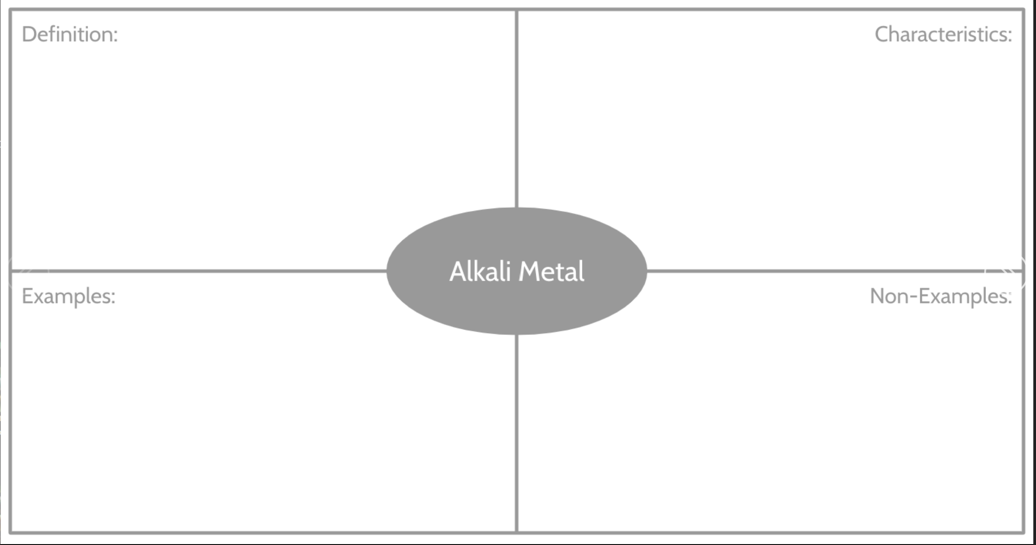

*Substances that are made up of two or more different atoms chemically joined together*

*More than one type of atom from periodic table*

*Chemically bonded and not easily separated*

*Carbon C*

*Oxygen O2*

*Hydrogen H2*

*Carbon dioxide CO2*

*Water H2O*

*Methane CH4*

**Oracy in Science**Once we have explicitly taught key words and definitions we need to provide opportunities for pupils to say them and use them in conversations. This is a step beyond choral response for knowledge checking.

Retrieval practice can be used as a good opportunity to develop oracy. When looking a recently taught knowledge, ask students to explain to the another student what it was they learnt last lesson or last week. Get each of them to pick previously taught knowledge from more than two weeks ago and they have five minutes to prepare and then they have to explain the concept/fact. They can use mini whiteboards to help them do this.   
  
Concept cartoons can be great for starting a discussion around a topic. These are still used a lot in primary but have fallen out of fashion a little in secondary. This is a shame as they are great for checking for understanding and also for initiating verbal responses using key vocabulary.

