Topic heading | Syllabus Ref | Idea cluster | Question 1 | Question 2 | Question 3 | Question 4
Inheritance, variation and evolution | BEv | Genetic Engineering | What are the function of enzymes in genetic engineering?  A They are used to aid the digestion of the chromosomes  B They are inserted into chromosomes in replacement of genes  C They are used to cut desired genes from chromosomes  D They are used to catalyse the reactions | Name an example of a vector and its use in genetic engineering  A Enzyme and it is used to cut a chromosome  B Bacteria, it is the desirable gene from a chromosome  C Plasmid, it is used to insert a gene into a required cell  D Plasmid, and it is used to cut a chromosome | What makes an organism ‘genetically modified’?  A It has had extra chromosomes inserted  B It has had extra genes added  C It has had a gene replaced by a different gene  D It has different alleles to another animal of the same species. | Which of the below is a concern related to genetic modification of crops?  A They have higher yields  B They may cross pollinate with wild plant populations  C They are resistant to pests  D They produce bigger fruits
 |  |  | C | C | C | B
Inheritance, variation and evolution | BEv | Evidence for evolution | Which individuals are most likely to survive to reproduce?  A Individuals that are well suited to their environment  B Individuals that are poorly suited to their environment  C Individuals that have no immunity to new diseases  D Individuals that have a restricted and small food supply | What is the theory for natural selection?  A Organisms that are well suited to their environment will go on to reproduce  B Organisms that are not well adapted to their environment will go on to reproduce  C Organisms that are well suited to their environment are likely to become extinct  D Organisms, over their life time, will adapt and pass on these characteristics in their genes to their young | For what reason may an organism become extinct?  A An increase in food supply  B A new predator  C A developed resistance to a disease  D An increase in territory | In what ways may fossils be formed?  A From parts of organisms that have not decayed  B When parts of the organisms are replaced by minerals  C As preserved traces of organisms eg footprints  D All of the above
 |  |  | A | A | B | D
Inheritance, variation and evolution | BEv | Classification of living organisms | Which of the following shows the correct genus and species of a Orang Utan?  A Mammal, Pongo  B pongo pygmaeus  C Pongo pygmaeus  D Chordate, Pongo. | Which of the following groups contain primitive unicellular organisms that live in extreme conditions?  A Bacteria  B Chordates  C Archaea  D Eukaryota | Which is the correct order for the classification system?  A Kingdom, Phylum, Order, Class, Family, Species, Genus  B Kingdom, Phylum, Class, Order, Family, Species, Genus  C Kingdom, Class, Phylum, Order, Family, Species, Genus  D Kingdom, Phylum, Class, Order, Family, Genus, Species | 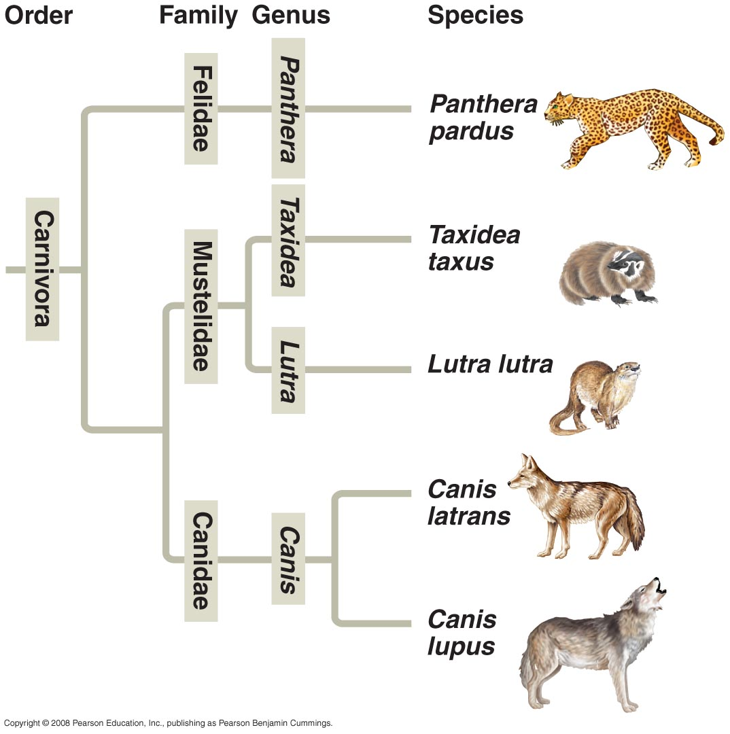  Which organism is the Taxidea taxus most closely related to?  A Canis Lupus  B Lutra lutra  C Canis latrans  D Panthera pardus
 |  |  | C | C | D | B

