Embedding Exam Practice in the Science Curriculum

It is vital for children to become familiar with exam board resources before they get near any mock or real exams.

Understanding the style, structure and language of the questions from as early as possible in KS4 will allow children to be better prepared to sit the real exam papers in Year 11

Exam questions shouldn’t really just be found in exam papers. They can be embedded across your curriculum to increase confidence, apply and retrieve knowledge. Although we should be cautious about throwing too many exams at pupils and not bringing down too many GCSE exam questions into KS3, there are many benefits to exposing pupils to exam questions frequently in low stakes situations. Below are some examples of how you can do this.

**Application of Knowledge questions The AoK Strategy.**

After a sequence of teaching knowledge and checking for secure understanding, you would want to provide children with opportunities to apply that knowledge in a context.

This can take a number of forms like a proper scientific enquiry challenge or attempting a challenging exam question.   
Longer 4-6 mark questions are good for this, e.g. required practical method questions. They can be peer marked, redrafted and then teacher marked for further improvements.

These should not just be random and left up to individual teachers. They should be pre-planned and sequenced in the curriculum at appropriate points to make sure they are given at the right time.

Once sequenced in the curriculum, the teacher when they reach this point will provide the pupils with the question and they will have a go. This should be under exam conditions at this point with roughly the time needed to answer the question, e.g. 6 marks = 6 minutes.

This is then peer assessed against the marking criteria and improvements suggested. A complete redraft is then attempted, again under exam conditions.

The teacher then marks the redraft and suggests further improvements or questions them further to probe deeper understanding. You can see this in action in the images below.

You can see in the three images that the first draft has been peer-assessed and key missing areas identified.

The redraft is then completed (here in green pen) and then teacher marked. The teacher also posed a further probing question which the pupil responded to.

**Exam questions as part of retrieval practice**

Providing plenty of opportunities for exam questions can be tricker when there is a lot of content to teach so including them as part of your retrieval practice routine allows for more exposure under low-stakes situations.   
Shorter 2-3 mark questions can be incorporated into retrieval practice with ease.

In this school, at the start of every lesson children are given one of these sheets. It has some standard retrieval questions from the last lesson and from a long time ago but at the bottom has a short 2-3 mark exam question for pupils to attempt. Depending on the set there may be some hints or guidance next to the question too.

**Walking Talking Mock (WTM)**

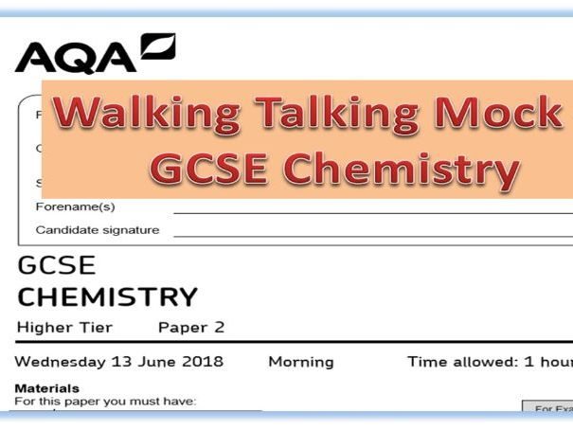Walking talking mocks are a useful way of prepping students for exams but without the high stakes pressure of a full mock exam.   
It involves setting up an exam-like situation in a hall. The teacher in charge of the WTM has chosen a paper and prepped for some of the major question sequences (not all of the paper).  
The Teacher will lead the paper from the front directing students to the questions, getting them to underline command words, point out any tricks or common mistakes (examiner report issues,) and guide them through the question(s). Using a visualiser to model how to work through a question is far more useful than PowerPoint slides as its live and pupils can replicate you in real-time.   
Some retrieval of the domain knowledge the question sits in is also useful at this point. The WTM can be done in the classroom, but works better in the hall where real exams will take place.

**End of topic tests/ mock exam reviews**

A common practice for end-of-topic tests and mock exams is to sit the class down and go through each question one by one.   
This has some problems. The students who did well will switch off. The students who didn’t do well are just getting that failure reinforced as they are forced to sit through question after question where it was either wrong or blank. It’s not enjoyable for them or beneficial for them either.

A better approach is for the teacher to identify two or three questions that the majority of the class got wrong. Then spend some time reteaching some of the core knowledge from that domain. Show where most went wrong in the question and how it should have been answered using a visualiser. Then give students another similar question from the same knowledge domain to attempt and then mark this together as a class.