***I do, we do, you do SLOP***

***Shed Loads of Practice Booklet***

**(SLOP)**

**Biology Topic 2**

**Organisation**

**Answers**

**Section 1 – Digestion**

**Section 2 – Food tests**

**Section 3- Enzymes**

**Section 4 – Lungs**

**Section 5- The heart**

**Section 6 – Blood and blood vessels**

**Section 7 – Non-communicable diseases**

**Section 8 – Cancer**

**Section 9 - Plants**

**Section 1- Digestion**

1. **Organisation**
2. What is the definition of a cell? Write this out 5 times.   
   The basic unit of life
3. What is the definition of a tissue? Write this out 5 times.  
   A collection of similar cells that work together to perform a function
4. What is the definition of an organ? Write this out 5 times.  
   A group of different tissues that work together to perform a function
5. What is the definition of an organ system? Write this out 5 times.

A group of organs that work together to perform a function

1. **Digestive organs**
2. What are the 10 organs of the digestive system?  
   Mouth, oesophagus, stomach, liver, gall bladder, pancreas, small intestine, large intestine, rectum, anus
3. What is the function of the mouth in digestion?   
   To chew food and mix it with saliva
4. What is the function of the oesophagus in digestion?  
   To push food down to the stomach via peristalsis
5. What is the function of the stomach in digestion?  
   Churn food with hydrochloric acid
6. What is the function of the liver in digestion?  
   Produce bile to neutralise hydrochloric acid as it leave the stomach and to help digest lipids
7. What is the function of the small intestine in digestion?  
   To absorb nutrients from food
8. What special structures does the small intestine have to help with its function?   
   Villi (and microvilli)
9. What is the function of the large intestine in digestion?  
   To absorb water from food
10. What is the function of the rectum in digestion?  
    To store stool
11. What is the function of the anus in digestion?  
    Where waste exits the body

**Section 2 – Food tests**

1. What is used to test for starch?  
   Iodine solution
2. What is used to test for protein?  
   Biurets solution
3. What is used to test for lipids?  
   Ethanol or Sudan III
4. What is used to test for reducing sugars?  
   Benedict’s solution
5. What is a positive result in the test for starch?  
   Blue/black colour
6. What is a positive result in the test for protein?  
   Purple colour
7. What is a positive result in the test for lipids?  
   Cloudy or red layer on top
8. What is a positive result in the test for reducing sugars?  
   Red colour
9. A test for starch produced a brown/orange colour. Is this a positive result?  
   No
10. A test for proteins produced a purple colour. Is this a positive result?  
    Yes
11. A test for reducing sugar gave a green colour. What does this mean?  
    A little reducing sugar present
12. A test for reducing sugar gave a blue colour. What does this mean?  
    no reducing sugar present
13. A test for reducing sugar gave a red colour. What does this mean?  
    A lot of reducing sugar present

**Section 3 – Enzymes**

1. What is a catalyst? Write this out 5 times  
   A substance that speeds up the rate of a reaction without being used up
2. What type of catalyst is an enzyme?  
   Biological
3. Look at the diagram of an enzyme, what is the name for the part labelled A?   
   Active site
4. What is the name for the substance that fits into part A?  
   Substrate
5. What is the name for the model of enzyme action?

Lock and key model

1. What are the 3 digestive enzymes?  
   Carbohydrase, protease, lipase
2. Which enzyme is produced in the mouth?  
   Carbohydrase (amylase)
3. Which enzyme is produced in the stomach?  
   Protease
4. Which enzymes are produced in the pancreas?  
   Carbohydrase, protease, lipase
5. What are carbohydrates broken down into?  
   Glucose
6. What are proteins broken down into?  
   Amino acids
7. What are lipids broken down into?   
   Fatty acids and glycerol
8. Name 3 factors that could affect the rate of enzyme action.   
   Temperature, pH, surface area, substrate concentration, pressure, enzyme concentration
9. What does it mean if an enzyme is denatured?  
   The shape of the enzymes active site has changed
10. What is the optimum temperature for enzymes in humans?  
    36-37°C
11. What would be an optimum pH for an enzyme found in the stomach?  
    1-3
12. What would be the optimum pH for an enzymes found in the small intestine?  
    6-7

**Section 4 – Lungs**

1. What is the part labelled A in the diagram?  
   Larynx
2. What is the part labelled B in the diagram?  
   Trachea
3. What is the part labelled C in the diagram?  
   Rings of cartilage
4. What is the part labelled D in the diagram?  
   Bronchus
5. What is the part labelled E in the diagram?  
   Bronchioles
6. What is the part labelled F in the diagram?  
   Alveoli
7. What is the function of the lungs?  
   To facilitate gas exchange
8. How are the alveoli adapted to their function?   
   1 cell thick/short diffusion distance, large surface area, network of capillaries
9. What does smoking do to your lung capacity?  
   Decreases lung capacity
10. Which chemical from cigarettes binds to the haemoglobin in your red blood cells instead of oxygen?  
    Carbon monoxide
11. Name a disease that someone who smoked is at an increased risk of getting.   
    Lung cancer, respiratory infection, emphysema, heart disease

**Section 5 – The Heart**

1. **Structure of the heart**
2. Which part of the heart is labelled A?  
   Vena cava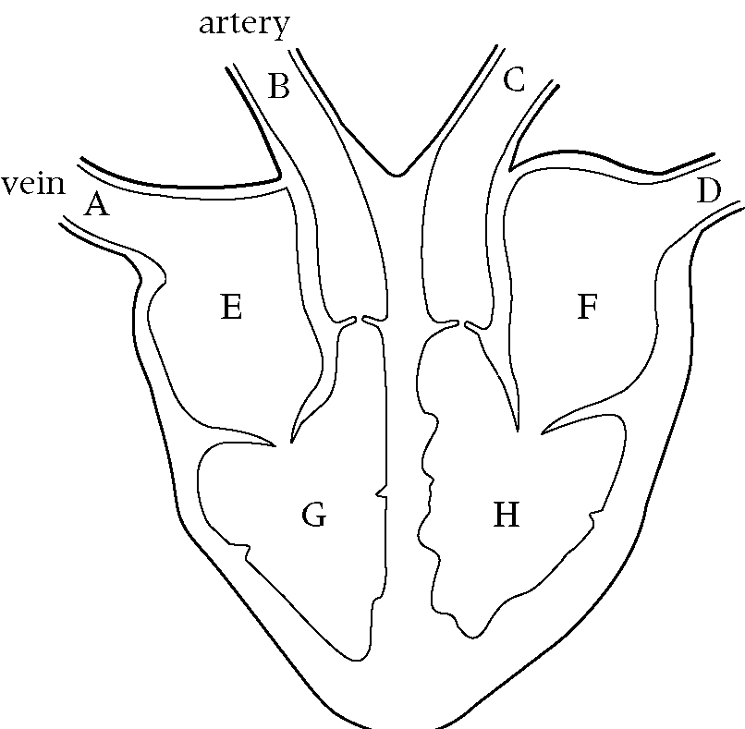
3. Which part of the heart is labelled B?  
   Pulmonary artery
4. Which part of the heart is labelled C?  
   Aorta
5. Which part of the heart is labelled D?  
   Pulmonary vein
6. Which part of the heart is labelled E?  
   Right atrium
7. Which part of the heart is labelled F?  
   Left atrium
8. Which part of the heart is labelled G?  
   Right ventricle
9. Which part of the heart is labelled H?  
   Left ventricle
10. Which blood vessels take blood to the heart?  
    Veins
11. Which blood vessels take blood away from the heart?  
    Arteries
12. Which side of the heart has oxygenated blood?  
    Left
13. Which side of the heart has deoxygenated?   
    Right
14. Describe the how deoxygenated blood enters the heart and then leaves as oxygenated blood.   
    Deoxygenated blood comes from the body into the heart via the vena cava.  
    The right atrium contracts and blood moves through the (tricuspid) valve into the right ventricle.  
    The right ventricle contracts and moves through the (pulmonary) valve into and out of the pulmonary artery to the lungs to pick up oxygen.   
    Oxygenated blood comes into the heart (from the lungs) via the pulmonary vein into the left atrium.   
    The left atrium contracts and blood moves through the (mitral) valve into the left ventricle.   
    The left ventricle contracts and blood moves through the aortic valve into and out of the aorta to the rest of the body.
15. **Heart Disease**
16. What is cardiovascular disease? Write this out 5 times.  
    Cardiovascular disease (CVD) is a general term for conditions affecting the heart or blood vessels.
17. What is coronary heart disease? Write this out 5 times.  
    Coronary heart disease occurs when the flow of oxygen-rich blood to the heart muscle is blocked or reduced.
18. What is arrhythmia?  
    A condition when the heart beat is irregular
19. What is a myocardial infarction?  
    When the blood flow to the heart muscle is suddenly blocked
20. What is heart failure?  
    Heart failure means that the heart is unable to pump blood around the body properly.
21. What is heart valve disease?  
    When a heart valve is doesn’t work properly in one of two ways; either the valve doesn’t open fully or the valve does not close properly.
22. Name 4 factors that could increase the risk of heart disease.  
    Smoking, high blood pressure, high cholesterol, diabetes, lack of exercise, age, sex, stress, family history
23. What is a stent and how does it work?  
    A balloon like structure made of mesh, that is inserted to a blocked artery to open it up for blood to flow through.
24. Name an advantage of a stent  
    Lowers the risk of CHD. Long term. Short recovery time
25. Name a disadvantage of a stent  
    Risk of blood clots and artery damage
26. What are statins and how do they work?  
    A type of drug that lowers the level of ‘bad’ cholesterol. It blocks/inhibits that enzyme that makes cholesterol in the liver.
27. Name an advantage of using statins  
    Reduces risk of strokes, CHD and heart attacks
28. Name a disadvantage of using stains  
    Has to be taken regularly, not an instant effect, can cause side effects.
29. What is a pacemaker and how does it work?  
    A small device containing a battery that is implanted in the chest and produces electrical signals to help the heart beat normally.
30. Name an advantage of a pacemaker  
    Gives the person more energy and a regular heart beat
31. Name a disadvantage of a pacemaker  
    Not a cure and will not prevent heart disease. Possibility of infection and surgical site
32. What are beta blockers and how to they work?  
    A drug that decreases the activity of the heart by blocking the action of hormones like adrenaline.
33. Name an advantage of beta blockers  
    Can treat a range of heart problems and reduce blood pressure
34. Name a disadvantage of beta blockers  
    Can affect the control of blood sugar levels. Can trigger asthma attacks.
35. What is an artificial valve and how does it work?  
    A made made/artificial or biological heart valve that replaces a fault one.
36. Name an advantage of an artificial valve  
    Increases quality of life, lasts a long time.
37. Name a disadvantage of an artificial valve.   
    Artificial – need medication to stop blood from clotting  
    Biological – only lasts around 15 years

**Section 6 - Blood and blood vessels**

1. **The blood**
2. What are the 4 components of the blood? Write these out 5 times.   
   Red blood cells, white blood cells, platelets, plasma
3. What is the function of red blood cells?  
   Transport oxygen around the body for aerobic respiration
4. What adaptations do red blood cells have?  
   No nucleus, biconcave, haemoglobin, thin membrane
5. What is the function of white blood cells?  
   Ingesting pathogens and producing antibodies
6. Where are red and white blood cells produced?  
   Bone marrow
7. What is the function of platelets?  
   Help the body form clots to stop bleeding
8. What is the function of plasma?   
   The liquid part of the blood that transports carbon dioxide, digested food, urea, hormones and heat.
9. **Blood vessels**
10. What are the 3 types of blood vessel? Write these out 5 times.   
    Veins, arteries, capillaries
11. What is the function of a vein? Write this out 5 times.  
    Carry blood towards the heart
12. What is the function of an artery? Write this out 5 times

Carry blood away from the heart

1. What is the function of a capillary? Write this out 5 times.  
   Allows diffusion of gases and nutrients from the blood to the body cells
2. What are the features of a vein?  
   Large lumen, thinner walls and valves
3. What are the features of an artery?  
   Smaller lumen, thick and muscular walls.
4. What are the features of a capillary?   
   1 cell thick and very small lumen that allow 1 cell through at a time.
5. Which blood vessel contain valves?  
   Veins
6. What is the function of the valves in a blood vessel?  
   To prevent backflow of blood
7. Which blood vessel is 1 cell thick?  
   Capillaries
8. Why is this blood vessel one cell thick?  
   To provide a short diffusion distance
9. Which blood vessel has a thick muscular layer?  
   Arteries
10. Why does this blood vessel have a thick muscular layer?   
    Too maintain high blood pressure

**Section 7 – Non-communicable diseases**

1. What is the definition of health? Write this out 5 times.   
   Health is the state of your physical and mental wellbeing.
2. What is the definition of a disease? Write this out 5 times  
   A disease is any abnormal condition that causes disruption in the functions of the body.
3. What is a risk factor? Write this out 5 times.   
   Any aspect of a lifestyle or substance in your body that increases the risk of developing a disease.
4. What are the two types of disease?  
   Communicable and non-communicable
5. Which type of disease of caused by a pathogen?  
   Communicable
6. Which type of disease is not caused by a pathogen?  
   Non-communicable
7. What is a communicable disease?  
   A disease caused by a pathogen that can be passed on (is contagious)
8. What is a non-communicable disease? Write this out 5 times.  
   A disease not caused by a pathogen and cannot be passed on (is not contagious)
9. Name 4 examples of a non-communicable diseases  
   Cancer, heart disease, diabetes, eczema, asthma, arthritis
10. For the non-communicable diseases, you listed in question j, state the risk factors of getting them.   
    Smoking, poor diet, age, sex, lack of exercise, genetics, carcinogens, alcohol

**Section 8 – Cancer**

1. What is the definition of cancer? Write this out 5 times  
   When some of the body’s cells begin to divide without stopping. They can spread around the body.
2. What is different about tumour cells compared to normal cells?  
   The cells in a tumour do not respond to the mechanisms that usual control cell division. They divide rapidly and uncontrollably.
3. What is a mutation? Write this out 5 times.   
   A random change in DNA
4. What is a tumour?  
   A collection of rapidly dividing cells
5. What are the 2 types of tumour?  
   Benign and malignant
6. What is a benign tumour? Write this out 5 times  
   Non-cancerous and do not spread.
7. What is a malignant tumour? Write this out 5 times.  
   Cancerous and spread
8. Which type of tumour is not cancerous?  
   Benign
9. Which type of tumour is cancerous?   
   Malignant
10. Name 3 risk factors of getting cancer  
    Smoking, age, genetics, alcohol, carcinogens, sunlight, radiation, diet, infectious agents

**Section 9 – Plants**

1. Structure of a leaf
2. Which part of the leaf is labelled A?  
   Waxy cuticle
3. Which part of the leaf is labelled B?  
   Upper epidermis
4. Which part of the leaf is labelled C?  
   Palisade layer
5. Which part of the leaf is labelled D?  
   Spongy mesophyll
6. Which part of the leaf is labelled E?  
   Stomata
7. Which part of the leaf is labelled F?  
   Guard cells
8. What is the function of a leaf?  
   To absorb sunlight for photosynthesis
9. What adaptations do leaves have?  
   Large surface area, lots of chloroplasts (chlorophyll), thin
10. What are stomata? Write this out 5 times  
    Stomata are openings on the bottom of a leaf.
11. They allow gases to diffuse in and out.
12. What are guard cells? Write this out 5 times  
    Guard cells control whether the stomata are open or closed
13. **Transpiration and transportation**
14. What is the function of a root hair cell? Write this out 5 times  
    The function of a root hair cell is to absorb water and minerals from the soil.
15. What is the function of the xylem? Write this out 5 times

Xylem tissue transport water and minerals from the roots to the leaves.

1. What is the function of the phloem? Write this out 5 times

Phloem tissue transports sugar (sucrose) and amino acids.

1. What is transpiration? Write this out 5 times  
   The movement of water from the roots to the leaves. Water can only move up the xylem.
2. What is transportation? Write this out 5 times  
   The movement of nutrients such as sugar around a plant. This can work both ways (up and down)
3. Describe how water enters, moves through a plant and then exits.   
   Roots (root hair cells) absorb water from the soil via osmosis. Water moves into the xylem (in the stem), this transports water up to the leaves. This is due to the ‘transpiration pull’ on the water from the evaporation of water through the stomata in the leaves.