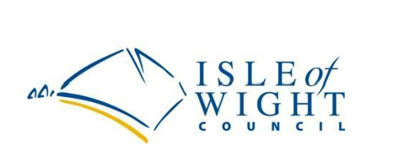



Safety in Secondary Science KS3 & KS4
Useful Links
Published June 2022

HIAS Science Moodle (hants.gov.uk)
HIAS science website
www.ase.org.uk
The Association for Science Education (ASE)
www.cleapss.org.uk
Consortium of Local Education Authorities for the Provision of Science Services (CLEAPSS)
www.hse.gov.uk/riddor
Health and Safety Executive (HSE)
STEM Learning - Resources, CPD, STEM Ambassadors and enrichment | STEM
National STEM centre for professional development for teachers and technicians
www.thefpa.co.uk
Fire Protection Association

