Topic heading | Syllabus Ref | Idea cluster | Question 1 | Question 2 | Question 3 | Question 4
Ecology | BEc1a | Adaptations, interdependence | An abiotic factor is:  - A non-living organic molecule affecting and ecosystem.  - A non-living factor affecting ecosystems such as sunlight  - A living factor that affects ecosystems such as the number of prey available.  - A living molecule affecting an ecosystem | A biotic factors is:  - A non-living organic molecule affecting and ecosystem.  - A non-living factor affecting ecosystems such as sunlight  - A living factor that affects ecosystems such as the number of prey available  - A living molecule affecting an ecosystem | An ecosystem is:  - The interaction between all the living and non-living things in an environment.  - Refers only to the living things in a specific area.  - Refers only to the non-living things in a specific area.  - Where an animal lives. | Factors plants compete for include:  - Space and light.  - Space, light and water.  - Space, light, water and mineral ions.  - Space, light, water, mineral ions and chloroplasts.
Answers |  |  | B | C | A | C.
Ecology | BEc2a | Levels of organisation | What is the primary source of energy for all ecosystems?  - Plants  - The sun  - Chemicals  - Water | All food chains must start off with:  - A primary consumer  - A secondary consumer  - Microorganisms  - A plant (or photosynthetic organism. | What is this piece of equipment called?  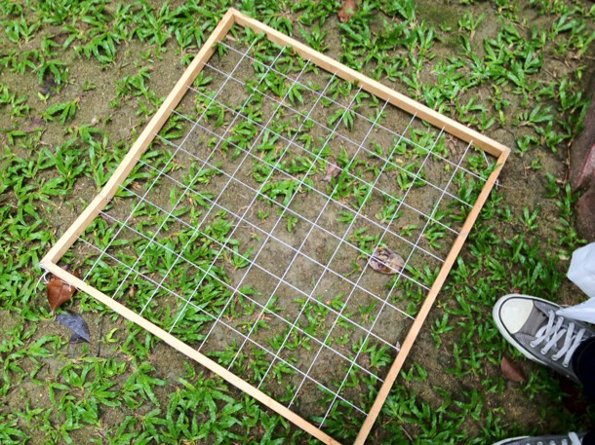  - A quadrat  - A line transect  - A random sampler  - A rectangle | Random sampling is used:  - To identify the number of species.  - To avoid bias when looking at data.  - To estimate the number of species in an area.  - To identify the distribution of species between two points of interest, such as between a foot path and some woods.
Answers |  |  | B | D | A | C

Topic heading | Syllabus Ref | Idea cluster | Question 5 | Question 6 | Question 7; | Question 8
Ecology | BEc1b | Adaptations, interdependence | Animals compete for:  - Food only  - Food and mates.  - Food, mates and territory.  - Food, mates, territory and oxygen | If the number of rabbits decreased from this ecosystem then the number of mice would likely:  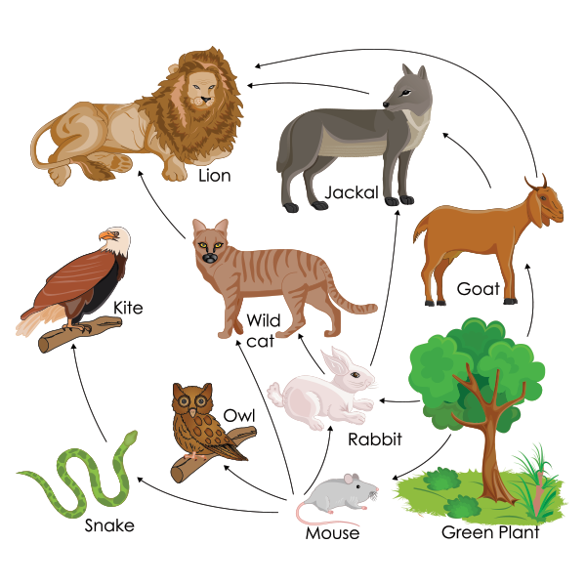  - Stay the same.  - Increase.  - Decrease.  - Be made extinct. | The ways living organisms interact is called:  - Denaturing  - Competition  - Predator-Prey relationships  - Interdependence | Adaptations may be:  - Structural  - Behavioural  - Structural or behavioural  - Structural, behavioural or functional.
Ecology
Answers |  |  | C | B | D | D
Ecology | EC2b | Levels of organisation | A line transect is used:  - To identify the number of species.  - To avoid bias when looking at data.  - To estimate the number of species in an area.  - To identify the distribution of species between two points of interest, such as between a foot path and some woods | The mean of these numbers: 3, 3, 5, 6 would be:  - 4.25  - 4.67  - 3  - 4 | The mode of these numbers: 3, 3, 5, 6 would be:  - 4.25  - 4.67  - 3  - 4 | The median of these numbers: 3, 3, 5, 6 would be:  - 4.25  - 4.67  - 3  - 4
Answers |  |  | D | A | C | D

Topic heading | Syllabus Ref | Idea cluster | Question 9 | Question 10
Ecology | BEc1c | Adaptations, interdependence | Organisms that survive in extreme conditions are called:  - Hardophiles  - Extremophiles  - Non-living  - Thermochromatic | An example of an extreme environment would be:  - The sun  - Deep sea vents  - Sewer systems  - The human stomach
Answers |  |  | B | B
Ecology | EC2b | Levels of organisation | What is the name given to this type of relationship:  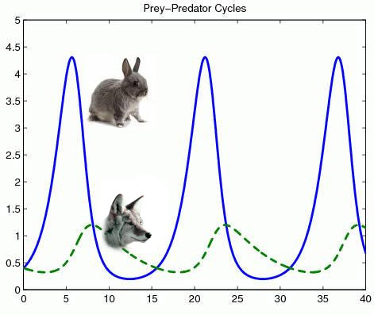  - Producer-consumer  - Consumer –prey  - Predator-prey  - Rabbit-fox |  | Which town is situated on an unpolluted river?  A A  B B  C C  D D
 |  |  | C |  | D
Ecology | EC2c | How materials are cycled | Below is a diagram of the carbon cycle: | Which process releases water vapour to the atmosphere?  A Transpiration  B Condensation  C Precipitation  D Absorption |  | Which process removes water vapour from the atmosphere?  A Evaporation  B Condensation  C Nitrogen fixation  D Neutralisation
 |  |  | D | A |  | B
Ecology | Ec2c | Land Use and Global Warming | Large-scale deforestation in tropical areas has occurred to:  A Provide land for sunbathing and tourism  B Provide land for house building  C Provide land for cattle and rice fields  D Provide wood for burning in wood-fired stoves | Two greenhouse gases that contribute to global warming are:  A O₂ and CO₂  B SO₂ and O₂  C CO and NO₂  D CO₂ and CH₄ | What processes mean scientists have come to a consensus that global warming is real?  A Replicated experiments in the laboratory  B Presentation and graph seen of rising temperature at scientific conferences  C Systematic review of thousands of peer reviewed publications  D Sea levels have risen and the climate has changed | Which one of the following is not a way of reducing negative human effects on ecosystems and maintaining biodiversity?  A recycling resources (rather than landfill)  B removal of hedgerows on farming land  C breeding programmes for endangered species  D reduction of deforestation
 |  |  | C | D | C | B

